QUANTUM CAPACITANCE

Introduction

In 1988, quantum capacitance is a quantity that was introduced by Serge Luryi. The basic idea of quantum capacitance was found and tested in two-dimensional electron gas (2DEG) in a quantum well. The quantum capacitance in metal layer occur when the metal does not follow ordinary grounded metallic plane. It also does not completely screen an applied transverse electric field. Quantum capacitance is the capacitance that manifest itself as a new capacitance in series of other capacitance. The value for the capacitance follow the formula CQ=me2/πℏ2, where m is the effective electron mass in the direction transverse to the quantum well. Quantum capacitance also being called chemical capacitance and electrochemical capacitance by another researchers but still holds the same meaning.

In normal capacitance, two plates that being placed parallel to each other enable the electric fields from charges on one side of the plate to pass through the area between the plates. When the metal plate is grounded, it completely shields the metal plate from emanating the electric fields from one metal plate to another side. In three-plate capacitor in Figure 1.1, the middle plate is grounded thus making the slow transmission of the electric fields and changes the electric fields inside the space filled with dielectric ε1. When the middle plate Q is made of a two-dimensional (2D) metal for example 2DEG in quantum well or an inversion layer. The electric fields induced from charges on metal plate 1 can partially penetrate the middle plate Q and induces charges on metal plate 2. The total capacitance Ctot based on Figure 1.2 where is C1 and C2 are the geometric capacitances.

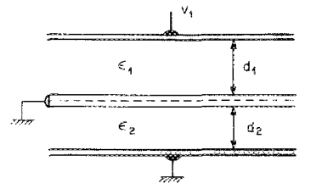

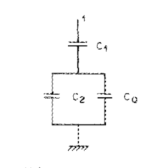

In the simplest example, if you make a parallel-plate capacitor where one or both of the plates has a low density of states, then the capacitance is not given by the normal formula for parallel-plate capacitors. Instead, the capacitance is lower, as if there was another capacitor in series. This second capacitance, related to the density of states of the plates, is the quantum capacitance.

Quantum capacitance is especially important for low-density-of-states systems, such as a 2-dimensional electronic system in a semiconductor surface or interface or graphene.

Overview

When a voltmeter is used to measure an electronic device, it does not quite measure the pure electric potential (also called Galvani potential). Instead, it measures the electrochemical potential, also called "fermi level difference", which is the total free energy difference per electron, including not only its electric potential energy but also all other forces and influences on the electron (such as the kinetic energy in its wavefunction). For example, a p-n junction in equilibrium, there is a galvani potential (built-in potential) across the junction, but the "voltage" across it is zero (in the sense that a voltmeter would measure zero voltage).

In a capacitor, there is a relation between charge and voltage, Q=CV. As explained above, we can divide the voltage into two pieces: The galvani potential, and everything else.

In a traditional metal-insulator-metal capacitor, the galvani potential is the only relevant contribution. Therefore, the capacitance can be calculated in a straightforward way using Gauss's law.

However, if one or both of the capacitor plates is a semiconductor, then galvani potential is not necessarily the only important contribution to capacitance. As the capacitor charge increases, the negative plate fills up with electrons, which occupy higher-energy states in the band structure, while the positive plate loses electrons, leaving behind electrons with lower-energy states in the band structure. Therefore, as the capacitor charges or discharges, the voltage changes at a different rate than the galvani potential difference.

In these situations, one cannot calculate capacitance merely by looking at the overall geometry and using Gauss's law. One must also take into account the band-filling / band-emptying effect, related to the density-of-states of the plates. The band-filling / band-emptying effect alters the capacitance, imitating a second capacitance in series. This capacitance is called quantum capacitance, because it is related to the energy of an electron's quantum wavefunction.

Some scientists refer to this same concept as chemical capacitance, because it is related to the electrons' chemical potential.[2]

The ideas behind quantum capacitance are closely linked to Thomas–Fermi screening and band bending.